K L UNIVERSITY
FRESHMAN ENGINEERING DEPARTMENT

A Project Based Lab Report On

ExamSphere – Adaptive Quiz & Exam Engine

SUBMITTED BY:
ID NUMBER NAME
2600030535 A.Jasmitha

UNDER THE ESTEEMED GUIDANCE OF Dr. D. Anand
ASSISTANT PROFESSOR



KL UNIVERSITY
Green fields, Vaddeswaram – 522 502 Guntur Dt., AP, India.

DEPARTMENT OF BASIC ENGINEERING SCIENCES-1



CERTIFICATE

This is to certify that the project based laboratory report entitled “ExamSphere – Adaptive Quiz & Exam Engine” submitted by S. Harsha Kovid, 2600030497 , to the BASIC ENGINEERING SCIENCES-1 , KL University in partial fulfillment of the requirements for the completion of a project based Laboratory in “Problem Solving using Programming (JAVA)(26SC1101)” course in I B Tech I Semester, is a Bonafide record of the work carried out by him/her under my supervision during the academic year 2026 – 2027.

PROJECT SUPERVISOR HEAD OF THE DEPARTMENT Dr. D. Anand Dr. D. HARITHA

ACKNOWLEDGEMENTS

It is great pleasure for me to express my gratitude to our honorable President.

Sri. Koneru Satyanarayana, for giving the opportunity and platform with facilities in accomplishing the project-based laboratory report.
I express sincere gratitude to our Director Dr. A. Jagdeesh for his administration towards our academic growth.
I express sincere gratitude to our Coordinator and HOD-BES1 Dr. D. Haritha for her leadership and constant motivation provided for then successful completion of our academic semester. I record it as my privilege to deeply thank you for providing us with the efficient faculty and facilities to make our ideas into reality.
I express my sincere thanks to our project supervisor Dr. D. Anand for her novel association of ideas, encouragement, appreciation, and intellectual zeal which motivated us to venture this project successfully.
Finally, we are pleased to acknowledge our indebtedness to all those who devoted themselves directly or indirectly to making this project a success.

Name: A.Jasmitha ID No: 2600030535

ABSTRACT

ExamSphere – Adaptive Quiz & Exam Engine is a Java-based application develop to provide personalized quizzes and examinations for students. Traditional assessment systems often provide the same set of questions to every student, even though students may have different levels of knowledge and learning abilities. ExamSphere addresses this problem by providing a system that manages students, questions, quizzes, examinations, results, and performance analysis in an organized manner.
The main feature of ExamSphere is the Adaptive Engine, which changes the difficulty level of questions according to the student's performance. When a student performs well, the system can move towards more difficult questions, while lower performance can lead to easier questions. This makes the assessment more suitable for the student's current level and provides a more interactive examination experience.
The system consists of different modules such as Student Module, Question Bank Module, Quiz & Examination Module, Adaptive Engine Module, Result Module, ValidateService, SearchService, ReportGenerationService, AnalysisService, and Main Module. These modules work together to manage the complete examination process, from student registration and question management to result generation and performance analysis.
The project demonstrates important Java programming concepts including Object-Oriented Programming, Classes and Objects, Encapsulation, Inheritance, Polymorphism, Java Collections, Exception Handling, File Handling, Lambda Expressions, and Stream API. These concepts are used to create a structured and maintainable application.
Overall, ExamSphere aims to make the assessment process more personalized, organized, interactive, and efficient. It provides a foundation for developing a smart examination system that can adapt to different student performance levels and provide useful information about their progress.

Key Words: Java, ExamSphere, Adaptive Quiz, Examination, Question Bank, Student Performance, Result Analysis, Adaptive Engine.

INDEX

S.NO | TITLE | PAGE NO
1 | Introduction | 6
2 | Aim of the Project | 7
2.1 | Advantages & Disadvantages | 8
2.2 | Future Implementation | 8
3 | Software & Hardware Details | 9
4 | Data Flow Diagram | 10-11
5 | Algorithm for each module | 12
6 | Implementation | 13-15
7 | Integration and System Testing | 16-18
8 | Conclusion | 19

INTRODUCTION
ExamSphere – Adaptive Quiz & Exam Engine is a Java-based application designed to provide personalized quizzes and examinations for students. Traditional assessment systems often use the same set of questions for every student, even though students may have different levels of knowledge and learning abilities. ExamSphere manages student registration, question banks, quizzes, examinations, results, and performance analysis in an organized system. Its main feature, the Adaptive Engine, changes the difficulty level of questions according to the student's performance. The system also provides grades, feedback, reports, and performance analysis, helping to reduce manual work and understand student progress. The project uses important Java concepts such as Object-Oriented Programming, Encapsulation, Inheritance, Polymorphism, Java Collections, Exception Handling, File Handling, Lambda Expressions, and Stream API. Overall, ExamSphere aims to make the examination process personalized, organized, interactive, and efficient.
ExamSphere also helps in reducing manual work by automating question selection, result calculation, grading, and performance analysis. This makes the assessment process easier for both students and teachers while providing useful information about student performance.

- Easy to learn
- Structured language
- It produces efficient programs.
- It can handle low-level activities.
- It can be compiled on a variety of computers.

AIM

The aim of ExamSphere – Adaptive Quiz & Exam Engine is to develop a Java-based examination system that provides personalized quizzes and examinations based on student performance. The system aims to manage students, questions, quizzes, results, and performance analysis in an organized manner. It uses an Adaptive Engine to adjust question difficulty according to the student's responses. The project also aims to reduce manual work, provide quick results and feedback, and make the assessment process more efficient, interactive, and personalized.

The modules in this project are -
→To provide an any time any place service for the customer.
→To minimize the number of staff at the ticket box.
→To promote the film on the internet.
→To increase the profit.

ADVANTAGES
→ Provides personalized questions based on student performance.
→ Automatically adjusts the difficulty level of questions.
→ Reduces manual work in question selection and result calculation.
→ Provides quick results, grades, and feedback.
→ Helps teachers analyze student performance easily.
→ Organizes student, question, quiz, and result information in one system.
→ Makes the examination process more interactive and efficient.

DISADVANTAGES
→ Requires proper question data to provide suitable questions.
→ The adaptive system may not always select the perfect difficulty level.
→ Initial development and setup may require more time.
→ The system depends on accurate student responses and stored data.
→ Technical errors may affect quiz, result, or report generation.
→ Regular maintenance and updates are required to keep the system effective.

FUTURE IMPLEMENTATION
In the future, ExamSphere – Adaptive Quiz & Exam Engine can be improved by developing a web or mobile version of the system and adding a larger question bank with different subjects and difficulty levels. Advanced adaptive algorithms can be used to improve question selection based on student performance. The system can also include secure online examinations, database storage, detailed performance reports, progress tracking, and AI-based recommendations to provide suitable questions and learning suggestions.

SYSTEM REQUIREMENTS

SOFTWARE REQUIREMENTS:
The major software requirements of the project are as follows: Language: Turbo-C.
Operating system: Windows 10 or more.
Technical requirements: Monitor, CPU, Keyboard, Mouse, etc...

HARDWARE REQUIREMENTS:
The hardware requirements that map towards the software are as follows: RAM: 8 GB.
Processor: i5/i7

DATA FLOW DIAGRAM

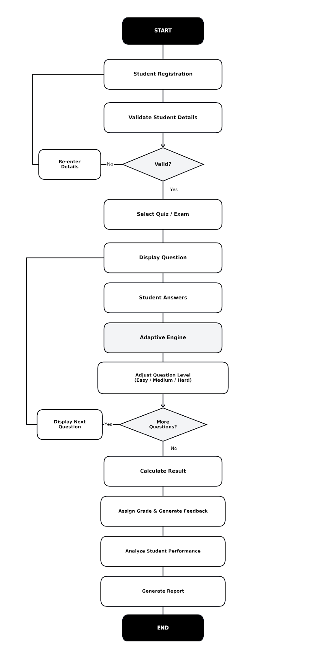
10

10

ALGORITHM
Step 1: Start
Step 2: Register the student by entering the required student details.
Step 3: Validate the entered student details.
Step 4: If the details are invalid, ask the student to re-enter the information.
Step 5: If the details are valid, allow the student to select a quiz or examination.
Step 6: Display the questions according to the selected quiz or examination.
Step 7: Accept and store the student's answers.
Step 8: Use the Adaptive Engine to analyze the student's performance and adjust the question difficulty | level.
Step 9: Evaluate the submitted answers and calculate the student's marks.
Step 10: Generate the result and performance summary.
Step 11: Analyze the student's performance using the result data.
Step 12: Display the final result and performance analysis.
Step 13: Stop

IMPLEMENTATION

package project3;
import java.util.*;
import java.util.stream.Collectors;

/*
* ============================================================
* EXAMSPHERE - ADAPTIVE QUIZ & EXAM ENGINE
* ============================================================
* Modules:
* 1. Student Module
* 2. Question Bank Module
* 3. Quiz & Examination Module
* 4. Adaptive Engine Module
* 5. Result Module
* 6. ValidateService Module
* 7. SearchService Module
* 8. ReportGenerationService Module
* 9. AnalysisService Module
* 10. Main Module
* ============================================================
*/

public class ExamSphereProject {

static Scanner sc = new Scanner(System.in);

// ==========================================================
// 1. STUDENT MODULE
// ==========================================================

static class Student {
private int studentId;
private String studentName;
private String department;
private String email;

public Student(int studentId, String studentName,
String department, String email) {
this.studentId = studentId;
this.studentName = studentName;
this.department = department;
this.email = email;
}

public int getStudentId() {
return studentId;
}

public String getStudentName() {
return studentName;
}

public String getDepartment() {
return department;
}

public String getEmail() {
return email;
}

public void updateStudent(String name, String department,
String email) {
this.studentName = name;
this.department = department;
this.email = email;
}

public void displayStudent() {
System.out.println("\n--- Student Details ---");
System.out.println("Student ID : " + studentId);
System.out.println("Student Name : " + studentName);
System.out.println("Department : " + department);
System.out.println("Email : " + email);
}
}

// ==========================================================
// 2. QUESTION BANK MODULE
// ==========================================================

static class Question {
private int questionId;
private String subjectCode;
private String questionText;
private String difficultyLevel;
private double marks;

public Question(int questionId, String subjectCode,
String questionText,
String difficultyLevel,
double marks) {

this.questionId = questionId;
this.subjectCode = subjectCode;
this.questionText = questionText;
this.difficultyLevel = difficultyLevel;
this.marks = marks;
}

public int getQuestionId() {
return questionId;
}

public String getSubjectCode() {
return subjectCode;
}

public String getQuestionText() {
return questionText;
}

public String getDifficultyLevel() {
return difficultyLevel;

13
public String getEmail() {
return email;
}

public void updateStudent(String name, String department,
String email) {
this.studentName = name;
this.department = department;
this.email = email;
}

public void displayStudent() {
System.out.println("\n--- Student Details ---");
System.out.println("Student ID : " + studentId);
System.out.println("Student Name : " + studentName);
System.out.println("Department : " + department);
System.out.println("Email : " + email);
}
}

// ==========================================================
// 2. QUESTION BANK MODULE
// ==========================================================

static class Question {
private int questionId;
private String subjectCode;
private String questionText;
private String difficultyLevel;
private double marks;

public Question(int questionId, String subjectCode,
String questionText,
String difficultyLevel,
double marks) {

this.questionId = questionId;
this.subjectCode = subjectCode;
this.questionText = questionText;
this.difficultyLevel = difficultyLevel;
this.marks = marks;
}

public int getQuestionId() {
return questionId;
}

public String getSubjectCode() {
return subjectCode;
}

public String getQuestionText() {
return questionText;
}

public String getDifficultyLevel() {
return difficultyLevel;
}
}

public double getMarks() {
return marks;
}

public void displayQuestion() {
System.out.println("\nQuestion ID : " + questionId);
System.out.println("Subject Code : " + subjectCode);
System.out.println("Question : " + questionText);
System.out.println("Difficulty Level : " + difficultyLevel);
System.out.println("Marks : " + marks);
}
}

// ==========================================================
// 3. QUIZ & EXAMINATION MODULE
// ==========================================================

static class QuizExam {
private int quizId;
private String quizTitle;
private String subjectCode;
private int duration;
private double totalMarks;

public QuizExam(int quizId, String quizTitle,
String subjectCode, int duration,
double totalMarks) {

this.quizId = quizId;
this.quizTitle = quizTitle;
this.subjectCode = subjectCode;
this.duration = duration;
this.totalMarks = totalMarks;
}

public int getQuizId() {
return quizId;
}

public String getQuizTitle() {
return quizTitle;
}

public String getSubjectCode() {
return subjectCode;
}

public int getDuration() {
return duration;
}

public double getTotalMarks() {
return totalMarks;
}

public void displayQuiz() {
14

public double getMarks() {
return marks;
}

public void displayQuestion() {
System.out.println("\nQuestion ID : " + questionId);
System.out.println("Subject Code : " + subjectCode);
System.out.println("Question : " + questionText);
System.out.println("Difficulty Level : " + difficultyLevel);
System.out.println("Marks : " + marks);
}
}

// ==========================================================
// 3. QUIZ & EXAMINATION MODULE
// ==========================================================

static class QuizExam {
private int quizId;
private String quizTitle;
private String subjectCode;
private int duration;
private double totalMarks;

public QuizExam(int quizId, String quizTitle,
String subjectCode, int duration,
double totalMarks) {

this.quizId = quizId;
this.quizTitle = quizTitle;
this.subjectCode = subjectCode;
this.duration = duration;
this.totalMarks = totalMarks;
}

public int getQuizId() {
return quizId;
}

public String getQuizTitle() {
return quizTitle;
}

public String getSubjectCode() {
return subjectCode;
}

public int getDuration() {
return duration;
}

public double getTotalMarks() {
return totalMarks;
}

public void displayQuiz() {
System.out.println("\n--- Quiz Details ---");
System.out.println("\n--- Quiz Details ---");
System.out.println("Quiz ID : " + quizId);
System.out.println("Quiz Title : " + quizTitle);
System.out.println("Subject Code : " + subjectCode);
System.out.println("Duration : " + duration + " minutes");
System.out.println("Total Marks : " + totalMarks);
}

public void startQuiz() {
System.out.println("\n--- Quiz Started ---");
System.out.println("Quiz : " + quizTitle);
System.out.println("Subject : " + subjectCode);
System.out.println("Duration : " + duration + " minutes");
System.out.println("All the best!");
}

public void submitQuiz() {
System.out.println("\n--- Quiz Submitted ---");
System.out.println("Quiz ID: " + quizId);
System.out.println("Quiz submitted successfully!");
}
}

// ==========================================================
// 4. ADAPTIVE ENGINE MODULE
// ==========================================================

static class AdaptiveEngine {
private String currentDifficulty;
private int correctAnswers;
private int incorrectAnswers;

public AdaptiveEngine() {
currentDifficulty = "Easy";
correctAnswers = 0;
incorrectAnswers = 0;
}

public void setPerformance(int correct, int incorrect) {
correctAnswers = correct;
incorrectAnswers = incorrect;
}

public void evaluatePerformance() {

System.out.println("\n--- Evaluate Performance ---");

System.out.println("Current Difficulty : "
+ currentDifficulty);

System.out.println("Correct Answers : "
+ correctAnswers);

System.out.println("Incorrect Answers : "
+ incorrectAnswers);

if (correctAnswers > incorrectAnswers) {
increaseDifficulty();
15
System.out.println("Quiz ID : " + quizId);
System.out.println("Quiz Title : " + quizTitle);
System.out.println("Subject Code : " + subjectCode);
System.out.println("Duration : " + duration + " minutes");
System.out.println("Total Marks : " + totalMarks);
}

public void startQuiz() {
System.out.println("\n--- Quiz Started ---");
System.out.println("Quiz : " + quizTitle);
System.out.println("Subject : " + subjectCode);
System.out.println("Duration : " + duration + " minutes");
System.out.println("All the best!");
}

public void submitQuiz() {
System.out.println("\n--- Quiz Submitted ---");
System.out.println("Quiz ID: " + quizId);
System.out.println("Quiz submitted successfully!");
}
}

// ==========================================================
// 4. ADAPTIVE ENGINE MODULE
// ==========================================================

static class AdaptiveEngine {
private String currentDifficulty;
private int correctAnswers;
private int incorrectAnswers;

public AdaptiveEngine() {
currentDifficulty = "Easy";
correctAnswers = 0;
incorrectAnswers = 0;
}

public void setPerformance(int correct, int incorrect) {
correctAnswers = correct;
incorrectAnswers = incorrect;
}

public void evaluatePerformance() {

System.out.println("\n--- Evaluate Performance ---");

System.out.println("Current Difficulty : "
+ currentDifficulty);

System.out.println("Correct Answers : "
+ correctAnswers);

System.out.println("Incorrect Answers : "
+ incorrectAnswers);

if (correctAnswers > incorrectAnswers) {
increaseDifficulty();
}
}
else if (incorrectAnswers > correctAnswers) {
decreaseDifficulty();
}

System.out.println("New Difficulty : "
+ currentDifficulty);
}

public void increaseDifficulty() {

if (currentDifficulty.equalsIgnoreCase("Easy")) {
currentDifficulty = "Medium";
}
else if (currentDifficulty.equalsIgnoreCase("Medium")) {
currentDifficulty = "Hard";
}
else {
currentDifficulty = "Hard";
}
}

public void decreaseDifficulty() {

if (currentDifficulty.equalsIgnoreCase("Hard")) {
currentDifficulty = "Medium";
}
else if (currentDifficulty.equalsIgnoreCase("Medium")) {
currentDifficulty = "Easy";
}
else {
currentDifficulty = "Easy";
}
}

public String getCurrentDifficulty() {
return currentDifficulty;
}

public void selectNextQuestion(
Question question1,
Question question2,
Question question3) {

System.out.println("\n--- Next Question ---");

if (question1 != null && question1.getDifficultyLevel()
.equalsIgnoreCase(currentDifficulty)) {

System.out.println(
"Selected Question: "
+ question1.getQuestionText());

System.out.println(
"Difficulty: "
+ question1.getDifficultyLevel());

return;
}
16
else if (incorrectAnswers > correctAnswers) {
decreaseDifficulty();
}

System.out.println("New Difficulty : "
+ currentDifficulty);
}

public void increaseDifficulty() {

if (currentDifficulty.equalsIgnoreCase("Easy")) {
currentDifficulty = "Medium";
}
else if (currentDifficulty.equalsIgnoreCase("Medium")) {
currentDifficulty = "Hard";
}
else {
currentDifficulty = "Hard";
}
}

public void decreaseDifficulty() {

if (currentDifficulty.equalsIgnoreCase("Hard")) {
currentDifficulty = "Medium";
}
else if (currentDifficulty.equalsIgnoreCase("Medium")) {
currentDifficulty = "Easy";
}
else {
currentDifficulty = "Easy";
}
}

public String getCurrentDifficulty() {
return currentDifficulty;
}

public void selectNextQuestion(
Question question1,
Question question2,
Question question3) {

System.out.println("\n--- Next Question ---");

if (question1 != null && question1.getDifficultyLevel()
.equalsIgnoreCase(currentDifficulty)) {

System.out.println(
"Selected Question: "
+ question1.getQuestionText());

System.out.println(
"Difficulty: "
+ question1.getDifficultyLevel());

return;
}

if (question2 != null && question2.getDifficultyLevel()
.equalsIgnoreCase(currentDifficulty)) {

System.out.println(
"Selected Question: "
+ question2.getQuestionText());

System.out.println(
"Difficulty: "
+ question2.getDifficultyLevel());

return;
}

if (question3 != null && question3.getDifficultyLevel()
.equalsIgnoreCase(currentDifficulty)) {

System.out.println(
"Selected Question: "
+ question3.getQuestionText());

System.out.println(
"Difficulty: "
+ question3.getDifficultyLevel());

return;
}

System.out.println(
"No question available at "
+ currentDifficulty + " level.");
}
}

// ==========================================================
// 5. RESULT MODULE
// ==========================================================

static class Result {
private int resultId;
private int studentId;
private int quizId;
private double marksObtained;
private String grade;

public Result(int resultId, int studentId,
int quizId, double marksObtained) {

this.resultId = resultId;
this.studentId = studentId;
this.quizId = quizId;
this.marksObtained = marksObtained;

assignGrade();
}

public int getResultId() {
17
if (question2 != null && question2.getDifficultyLevel()
.equalsIgnoreCase(currentDifficulty)) {

System.out.println(
"Selected Question: "
+ question2.getQuestionText());

System.out.println(
"Difficulty: "
+ question2.getDifficultyLevel());

return;
}

if (question3 != null && question3.getDifficultyLevel()
.equalsIgnoreCase(currentDifficulty)) {

System.out.println(
"Selected Question: "
+ question3.getQuestionText());

System.out.println(
"Difficulty: "
+ question3.getDifficultyLevel());

return;
}

System.out.println(
"No question available at "
+ currentDifficulty + " level.");
}
}

// ==========================================================
// 5. RESULT MODULE
// ==========================================================

static class Result {
private int resultId;
private int studentId;
private int quizId;
private double marksObtained;
private String grade;

public Result(int resultId, int studentId,
int quizId, double marksObtained) {

this.resultId = resultId;
this.studentId = studentId;
this.quizId = quizId;
this.marksObtained = marksObtained;

assignGrade();
}

public int getResultId() {
return resultId;
return resultId;
}

public int getStudentId() {
return studentId;
}

public int getQuizId() {
return quizId;
}

public double getMarksObtained() {
return marksObtained;
}

public String getGrade() {
return grade;
}

public void calculateScore() {

System.out.println(
"Marks Obtained: " + marksObtained);

assignGrade();
}

public void assignGrade() {

if (marksObtained >= 90) {
grade = "A";
}
else if (marksObtained >= 75) {
grade = "B";
}
else if (marksObtained >= 60) {
grade = "C";
}
else if (marksObtained >= 50) {
grade = "D";
}
else {
grade = "F";
}
}

public String generateFeedback() {

if (grade.equals("A")) {
return "Excellent performance!";
}
else if (grade.equals("B")) {
return "Very good performance. Keep improving!";
}
else if (grade.equals("C")) {
return "Good effort. You can improve further.";
}
else if (grade.equals("D")) {
return "You passed, but more practice is needed.";
18
}

public int getStudentId() {
return studentId;
}

public int getQuizId() {
return quizId;
}

public double getMarksObtained() {
return marksObtained;
}

public String getGrade() {
return grade;
}

public void calculateScore() {

System.out.println(
"Marks Obtained: " + marksObtained);

assignGrade();
}

public void assignGrade() {

if (marksObtained >= 90) {
grade = "A";
}
else if (marksObtained >= 75) {
grade = "B";
}
else if (marksObtained >= 60) {
grade = "C";
}
else if (marksObtained >= 50) {
grade = "D";
}
else {
grade = "F";
}
}

public String generateFeedback() {

if (grade.equals("A")) {
return "Excellent performance!";
}
else if (grade.equals("B")) {
return "Very good performance. Keep improving!";
}
else if (grade.equals("C")) {
return "Good effort. You can improve further.";
}
else if (grade.equals("D")) {
return "You passed, but more practice is needed.";
}
}
else {
return "More practice is required. Keep trying!";
}
}

public void displayResult() {

System.out.println("\n--- Result Details ---");

System.out.println("Result ID : "
+ resultId);

System.out.println("Student ID : "
+ studentId);

System.out.println("Quiz ID : "
+ quizId);

System.out.println("Marks Obtained : "
+ marksObtained);

System.out.println("Grade : "
+ grade);

System.out.println("Feedback : "
+ generateFeedback());
}
}

// ==========================================================
// 6. VALIDATESERVICE MODULE
// ==========================================================

static class ValidateService {

public static boolean validateStudentId(int id) {

return id > 0;
}

public static boolean validateEmail(String email) {

return email != null
&& email.contains("@")
&& email.contains(".");
}

public static boolean validateMarks(double marks) {

return marks >= 0;
}

public static boolean validateDifficulty(String difficulty) {

return difficulty.equalsIgnoreCase("Easy")
|| difficulty.equalsIgnoreCase("Medium")
|| difficulty.equalsIgnoreCase("Hard");
19
else {
return "More practice is required. Keep trying!";
}
}

public void displayResult() {

System.out.println("\n--- Result Details ---");

System.out.println("Result ID : "
+ resultId);

System.out.println("Student ID : "
+ studentId);

System.out.println("Quiz ID : "
+ quizId);

System.out.println("Marks Obtained : "
+ marksObtained);

System.out.println("Grade : "
+ grade);

System.out.println("Feedback : "
+ generateFeedback());
}
}

// ==========================================================
// 6. VALIDATESERVICE MODULE
// ==========================================================

static class ValidateService {

public static boolean validateStudentId(int id) {

return id > 0;
}

public static boolean validateEmail(String email) {

return email != null
&& email.contains("@")
&& email.contains(".");
}

public static boolean validateMarks(double marks) {

return marks >= 0;
}

public static boolean validateDifficulty(String difficulty) {

return difficulty.equalsIgnoreCase("Easy")
|| difficulty.equalsIgnoreCase("Medium")
|| difficulty.equalsIgnoreCase("Hard");
}
}

public static boolean validateStudent(
int id, String email) {

return validateStudentId(id)
&& validateEmail(email);
}
}

// ==========================================================
// 7. SEARCHSERVICE MODULE
// ==========================================================

static class SearchService {

public static Student searchStudent(
Student student1, Student student2,
Student student3, int studentId) {

if (student1 != null && student1.getStudentId() == studentId) {
return student1;
}

if (student2 != null && student2.getStudentId() == studentId) {
return student2;
}

if (student3 != null && student3.getStudentId() == studentId) {
return student3;
}

return null;
}

public static Question searchQuestion(
Question question1, Question question2,
Question question3, int questionId) {

if (question1 != null && question1.getQuestionId() == questionId) {
return question1;
}

if (question2 != null && question2.getQuestionId() == questionId) {
return question2;
}

if (question3 != null && question3.getQuestionId() == questionId) {
return question3;
}

return null;
}

public static QuizExam searchQuiz(
QuizExam quiz1, QuizExam quiz2, int quizId) {

if (quiz1 != null && quiz1.getQuizId() == quizId) {
20

public static boolean validateStudent(
int id, String email) {

return validateStudentId(id)
&& validateEmail(email);
}
}

// ==========================================================
// 7. SEARCHSERVICE MODULE
// ==========================================================

static class SearchService {

public static Student searchStudent(
Student student1, Student student2,
Student student3, int studentId) {

if (student1 != null && student1.getStudentId() == studentId) {
return student1;
}

if (student2 != null && student2.getStudentId() == studentId) {
return student2;
}

if (student3 != null && student3.getStudentId() == studentId) {
return student3;
}

return null;
}

public static Question searchQuestion(
Question question1, Question question2,
Question question3, int questionId) {

if (question1 != null && question1.getQuestionId() == questionId) {
return question1;
}

if (question2 != null && question2.getQuestionId() == questionId) {
return question2;
}

if (question3 != null && question3.getQuestionId() == questionId) {
return question3;
}

return null;
}

public static QuizExam searchQuiz(
QuizExam quiz1, QuizExam quiz2, int quizId) {

if (quiz1 != null && quiz1.getQuizId() == quizId) {
return quiz1;
return quiz1;
}

if (quiz2 != null && quiz2.getQuizId() == quizId) {
return quiz2;
}

return null;
}
}

// ==========================================================
// 8. REPORTGENERATION SERVICE MODULE
// ==========================================================

static class ReportGenerationService {

public static void generateReport(
Student student,
QuizExam quiz,
Result result) {

System.out.println("\n================================");
System.out.println(" EXAMSPHERE REPORT");
System.out.println("================================");

System.out.println("Student Name : "
+ student.getStudentName());

System.out.println("Student ID : "
+ student.getStudentId());

System.out.println("Department : "
+ student.getDepartment());

System.out.println("Quiz Title : "
+ quiz.getQuizTitle());

System.out.println("Subject : "
+ quiz.getSubjectCode());

System.out.println("Marks : "
+ result.getMarksObtained()
+ "/" + quiz.getTotalMarks());

System.out.println("Grade : "
+ result.getGrade());

System.out.println("Feedback : "
+ result.generateFeedback());

System.out.println("================================");
}
}

// ==========================================================
// 9. ANALYSISSERVICE MODULE
// ==========================================================
21
}

if (quiz2 != null && quiz2.getQuizId() == quizId) {
return quiz2;
}

return null;
}
}

// ==========================================================
// 8. REPORTGENERATION SERVICE MODULE
// ==========================================================

static class ReportGenerationService {

public static void generateReport(
Student student,
QuizExam quiz,
Result result) {

System.out.println("\n================================");
System.out.println(" EXAMSPHERE REPORT");
System.out.println("================================");

System.out.println("Student Name : "
+ student.getStudentName());

System.out.println("Student ID : "
+ student.getStudentId());

System.out.println("Department : "
+ student.getDepartment());

System.out.println("Quiz Title : "
+ quiz.getQuizTitle());

System.out.println("Subject : "
+ quiz.getSubjectCode());

System.out.println("Marks : "
+ result.getMarksObtained()
+ "/" + quiz.getTotalMarks());

System.out.println("Grade : "
+ result.getGrade());

System.out.println("Feedback : "
+ result.generateFeedback());

System.out.println("================================");
}
}

// ==========================================================
// 9. ANALYSISSERVICE MODULE
// ==========================================================

static class AnalysisService {

public static void analyzeResults(
Student student1, Result result1,
Student student2, Result result2,
Student student3, Result result3) {

double marks1 = result1.getMarksObtained();
double marks2 = result2.getMarksObtained();
double marks3 = result3.getMarksObtained();

double average = (marks1 + marks2 + marks3) / 3;

String topPerformer;
double highestMarks;

if (marks1 >= marks2 && marks1 >= marks3) {
topPerformer = student1.getStudentName();
highestMarks = marks1;
}
else if (marks2 >= marks1 && marks2 >= marks3) {
topPerformer = student2.getStudentName();
highestMarks = marks2;
}
else {
topPerformer = student3.getStudentName();
highestMarks = marks3;
}

String lowestPerformer;
double lowestMarks;

if (marks1 <= marks2 && marks1 <= marks3) {
lowestPerformer = student1.getStudentName();
lowestMarks = marks1;
}
else if (marks2 <= marks1 && marks2 <= marks3) {
lowestPerformer = student2.getStudentName();
lowestMarks = marks2;
}
else {
lowestPerformer = student3.getStudentName();
lowestMarks = marks3;
}

System.out.println("\n--- Performance Analysis ---");

System.out.println(student1.getStudentName() + " : " + marks1 + "%");
System.out.println(student2.getStudentName() + " : " + marks2 + "%");
System.out.println(student3.getStudentName() + " : " + marks3 + "%");

System.out.printf("\nAverage Marks : %.2f%%%n", average);
System.out.println("Highest Marks : " + highestMarks + "%");
System.out.println("Top Performer : " + topPerformer);
System.out.println("Lowest Marks : " + lowestMarks + "%");
System.out.println("Lowest Performer : " + lowestPerformer);
System.out.println("Students Analyzed : 3");
System.out.println("Overall Performance Summary Generated.");
22
static class AnalysisService {

public static void analyzeResults(
Student student1, Result result1,
Student student2, Result result2,
Student student3, Result result3) {

double marks1 = result1.getMarksObtained();
double marks2 = result2.getMarksObtained();
double marks3 = result3.getMarksObtained();

double average = (marks1 + marks2 + marks3) / 3;

String topPerformer;
double highestMarks;

if (marks1 >= marks2 && marks1 >= marks3) {
topPerformer = student1.getStudentName();
highestMarks = marks1;
}
else if (marks2 >= marks1 && marks2 >= marks3) {
topPerformer = student2.getStudentName();
highestMarks = marks2;
}
else {
topPerformer = student3.getStudentName();
highestMarks = marks3;
}

String lowestPerformer;
double lowestMarks;

if (marks1 <= marks2 && marks1 <= marks3) {
lowestPerformer = student1.getStudentName();
lowestMarks = marks1;
}
else if (marks2 <= marks1 && marks2 <= marks3) {
lowestPerformer = student2.getStudentName();
lowestMarks = marks2;
}
else {
lowestPerformer = student3.getStudentName();
lowestMarks = marks3;
}

System.out.println("\n--- Performance Analysis ---");

System.out.println(student1.getStudentName() + " : " + marks1 + "%");
System.out.println(student2.getStudentName() + " : " + marks2 + "%");
System.out.println(student3.getStudentName() + " : " + marks3 + "%");

System.out.printf("\nAverage Marks : %.2f%%%n", average);
System.out.println("Highest Marks : " + highestMarks + "%");
System.out.println("Top Performer : " + topPerformer);
System.out.println("Lowest Marks : " + lowestMarks + "%");
System.out.println("Lowest Performer : " + lowestPerformer);
System.out.println("Students Analyzed : 3");
System.out.println("Overall Performance Summary Generated.");
}

}
}

// ==========================================================
// 10. MAIN MODULE
// ==========================================================

static Student student1;
static Student student2;
static Student student3;

static Question question1;
static Question question2;
static Question question3;

static QuizExam quiz1;
static QuizExam quiz2;

static Result result1;
static Result result2;
static Result result3;

public static void main(String[] args) {

System.out.println(
"==========================================");

System.out.println(
" EXAMSPHERE - ADAPTIVE QUIZ & EXAM ENGINE");

System.out.println(
"==========================================");

// ------------------------------------------------------
// Sample Students
// ------------------------------------------------------

System.out.println("Enter Student ID");
int studentid=sc.nextInt();
System.out.println("Enter Student Name");
String studentname=sc.next();
System.out.println("Enter Student Department");
String department=sc.next();
System.out.println("Enter Student Email");
String studentemail=sc.next();

student1 = new Student(
studentid, studentname, department, studentemail);

student2 = new Student(
102, "Priya", "CSE", "priya@gmail.com");

student3 = new Student(
103, "Arjun", "CSE", "arjun@gmail.com");

student1.displayStudent();

23
}

// ==========================================================
// 10. MAIN MODULE
// ==========================================================

static Student student1;
static Student student2;
static Student student3;

static Question question1;
static Question question2;
static Question question3;

static QuizExam quiz1;
static QuizExam quiz2;

static Result result1;
static Result result2;
static Result result3;

public static void main(String[] args) {

System.out.println(
"==========================================");

System.out.println(
" EXAMSPHERE - ADAPTIVE QUIZ & EXAM ENGINE");

System.out.println(
"==========================================");

// ------------------------------------------------------
// Sample Students
// ------------------------------------------------------

Scanner sc = new Scanner(System.in);
System.out.println("Enter Student ID");
int studentid=sc.nextInt();
System.out.println("Enter Student Name");
String studentname=sc.next();
System.out.println("Enter Student Department");
String department=sc.next();
System.out.println("Enter Student Email");
String studentemail=sc.next();

student1 = new Student(
studentid, studentname, department, studentemail);

student2 = new Student(
102, "Priya", "CSE", "priya@gmail.com");

student3 = new Student(
103, "Arjun", "CSE", "arjun@gmail.com");

student1.displayStudent();

// ------------------------------------------------------

// ------------------------------------------------------
// Sample Questions
// ------------------------------------------------------

question1 = new Question(
1, "JAVA",
"What is a class in Java?",
"Easy", 2);

question2 = new Question(
2, "JAVA",
"Explain inheritance in Java.",
"Medium", 5);

question3 = new Question(
3, "JAVA",
"Explain polymorphism with example.",
"Hard", 10);

System.out.println("\n--- Question Bank ---");
question1.displayQuestion();
question2.displayQuestion();
question3.displayQuestion();

// ------------------------------------------------------
// Sample Quizzes
// ------------------------------------------------------

quiz1 = new QuizExam(
501, "Java Basics", "JAVA", 30, 100);

quiz2 = new QuizExam(
502, "Java Advanced", "JAVA", 45, 100);

quiz1.displayQuiz();
quiz1.startQuiz();

// ------------------------------------------------------
// Adaptive Engine
// ------------------------------------------------------

AdaptiveEngine engine = new AdaptiveEngine();

engine.setPerformance(7, 3);
engine.evaluatePerformance();
engine.selectNextQuestion(
question1, question2, question3);

// ------------------------------------------------------
// Results
// ------------------------------------------------------

result1 = new Result(1001, 101, 501, 85);
result2 = new Result(1002, 102, 501, 72);
result3 = new Result(1003, 103, 501, 90);

result1.calculateScore();
result1.displayResult();

24
// Sample Questions
// ------------------------------------------------------

question1 = new Question(
1, "JAVA",
"What is a class in Java?",
"Easy", 2);

question2 = new Question(
2, "JAVA",
"Explain inheritance in Java.",
"Medium", 5);

question3 = new Question(
3, "JAVA",
"Explain polymorphism with example.",
"Hard", 10);

System.out.println("\n--- Question Bank ---");
question1.displayQuestion();
question2.displayQuestion();
question3.displayQuestion();

// ------------------------------------------------------
// Sample Quizzes
// ------------------------------------------------------

quiz1 = new QuizExam(
501, "Java Basics", "JAVA", 30, 100);

quiz2 = new QuizExam(
502, "Java Advanced", "JAVA", 45, 100);

quiz1.displayQuiz();
quiz1.startQuiz();

// ------------------------------------------------------
// Adaptive Engine
// ------------------------------------------------------

AdaptiveEngine engine = new AdaptiveEngine();

engine.setPerformance(7, 3);
engine.evaluatePerformance();
engine.selectNextQuestion(
question1, question2, question3);

// ------------------------------------------------------
// Results
// ------------------------------------------------------

result1 = new Result(1001, 101, 501, 85);
result2 = new Result(1002, 102, 501, 72);
result3 = new Result(1003, 103, 501, 90);

result1.calculateScore();
result1.displayResult();

// ------------------------------------------------------

// ------------------------------------------------------
// Validation
// ------------------------------------------------------

System.out.println("\n--- Validation ---");

System.out.println(
"Student ID Valid : "
+ ValidateService.validateStudentId(101));

System.out.println(
"Email Valid : "
+ ValidateService.validateEmail(
"rahul@gmail.com"));

System.out.println(
"Marks Valid : "
+ ValidateService.validateMarks(85));

// ------------------------------------------------------
// Search Service
// ------------------------------------------------------

System.out.println("\n--- Search Service ---");

System.out.println("Enter Student ID to Search ");
int studentId=sc.nextInt();

Student foundStudent = SearchService.searchStudent(
student1, student2, student3, studentId);

if (foundStudent != null) {
System.out.println("Student Found!");
foundStudent.displayStudent();
}
else {
System.out.println("Student not found.");
}

System.out.println("\nEnter Question ID to Search ");
int questionId=sc.nextInt();

Question foundQuestion = SearchService.searchQuestion(
question1, question2, question3, questionId);

if (foundQuestion != null) {
System.out.println("\nQuestion Found!");
foundQuestion.displayQuestion();
}

// ------------------------------------------------------
// Submit Quiz
// ------------------------------------------------------

quiz1.submitQuiz();

// ------------------------------------------------------
// Generate Report
// ------------------------------------------------------
25
// Validation
// ------------------------------------------------------

System.out.println("\n--- Validation ---");

System.out.println(
"Student ID Valid : "
+ ValidateService.validateStudentId(101));

System.out.println(
"Email Valid : "
+ ValidateService.validateEmail(
"rahul@gmail.com"));

System.out.println(
"Marks Valid : "
+ ValidateService.validateMarks(85));

// ------------------------------------------------------
// Search Service
// ------------------------------------------------------

System.out.println("\n--- Search Service ---");

System.out.println("Enter Student ID to Search ");
int studentId=sc.nextInt();

Student foundStudent = SearchService.searchStudent(
student1, student2, student3, studentId);

if (foundStudent != null) {
System.out.println("Student Found!");
foundStudent.displayStudent();
}
else {
System.out.println("Student not found.");
}

System.out.println("Enter Question ID to Search ");
int questionId=sc.nextInt();

Question foundQuestion = SearchService.searchQuestion(
question1, question2, question3, questionId);

if (foundQuestion != null) {
System.out.println("\nQuestion Found!");
foundQuestion.displayQuestion();
}

// ------------------------------------------------------
// Submit Quiz
// ------------------------------------------------------

quiz1.submitQuiz();

// ------------------------------------------------------
// Generate Report
// ------------------------------------------------------
ReportGenerationService.generateReport(
student1, quiz1, result1);

// ------------------------------------------------------
// Analysis
// ------------------------------------------------------

AnalysisService.analyzeResults(
student1, result1,
student2, result2,
student3, result3);

System.out.println(
"\n==========================================");

System.out.println(
" EXAMSPHERE EXECUTION COMPLETED");

System.out.println(
"==========================================");
}
}

INTEGRATION AND SYSTEM TESTING
OUTPUTS

Screen Shots:

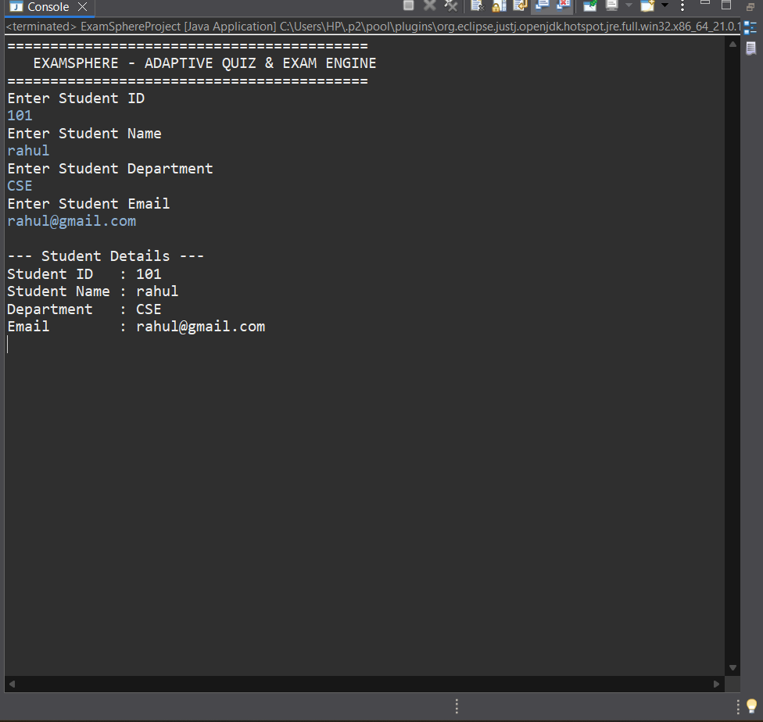

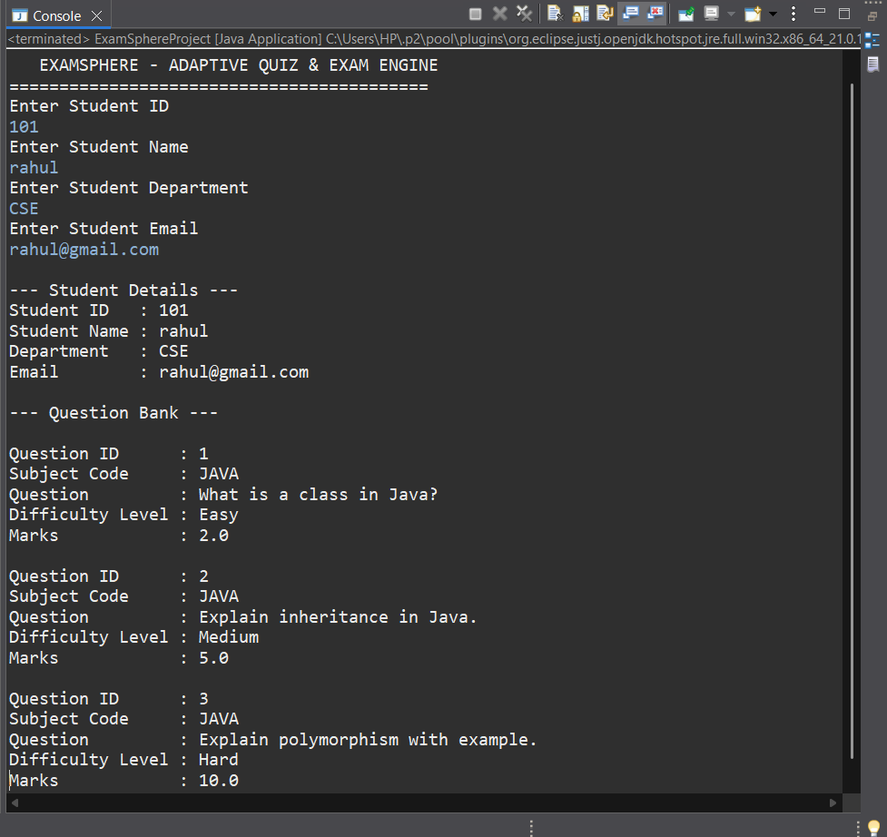

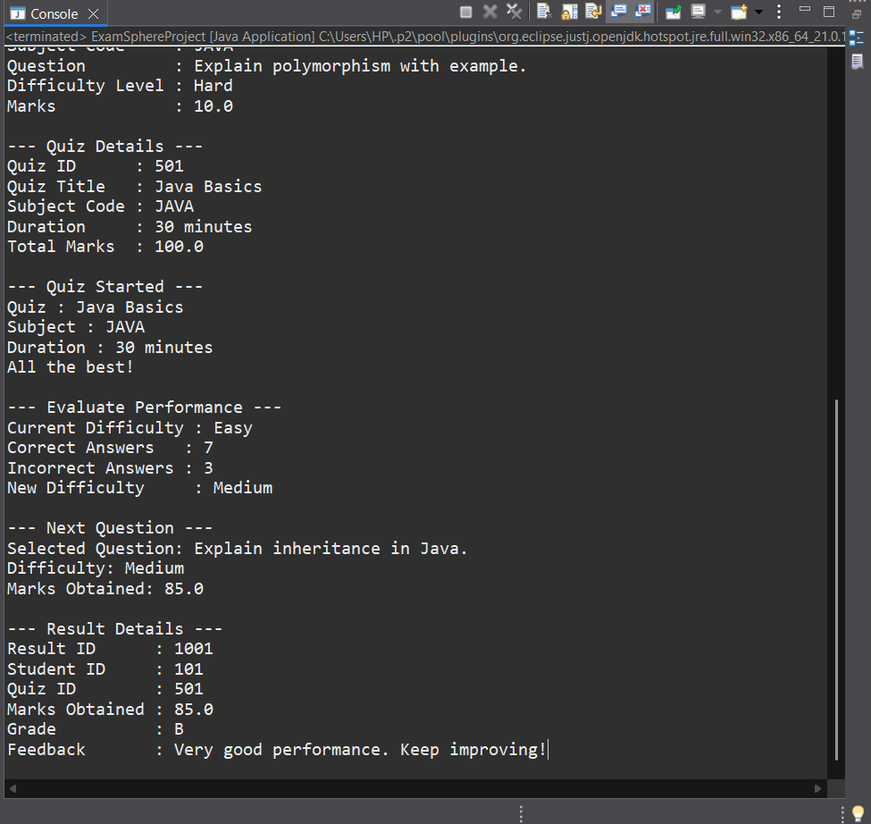

25

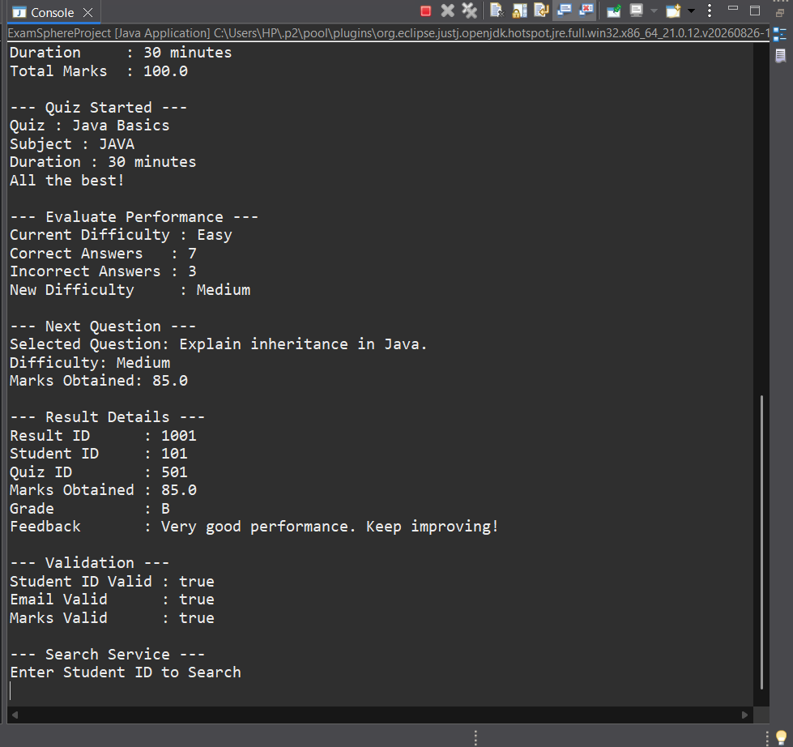

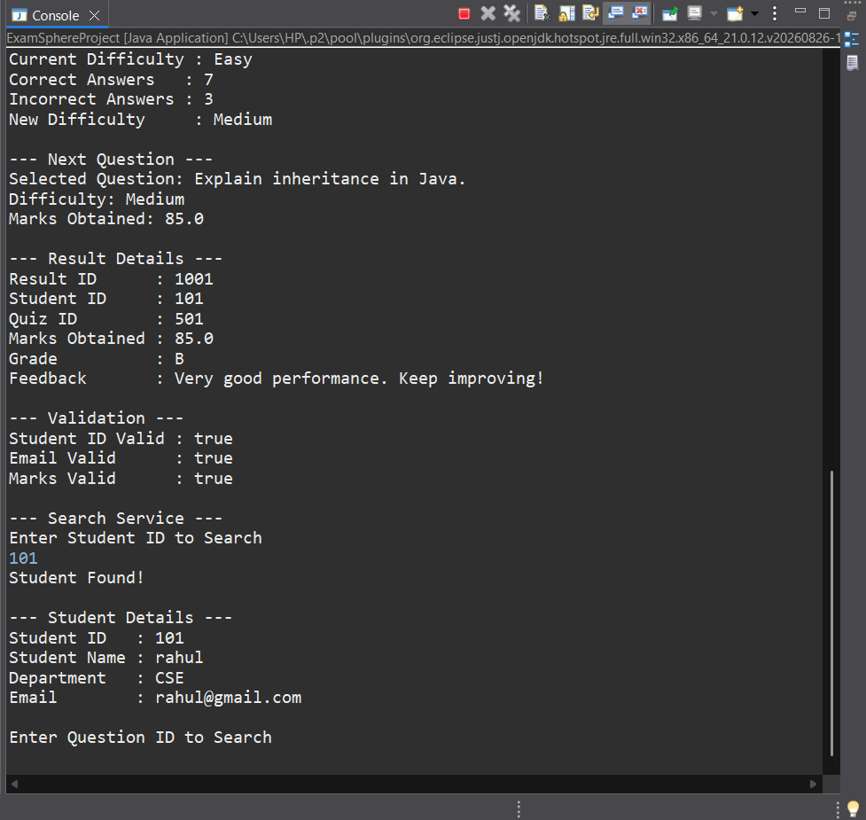
26

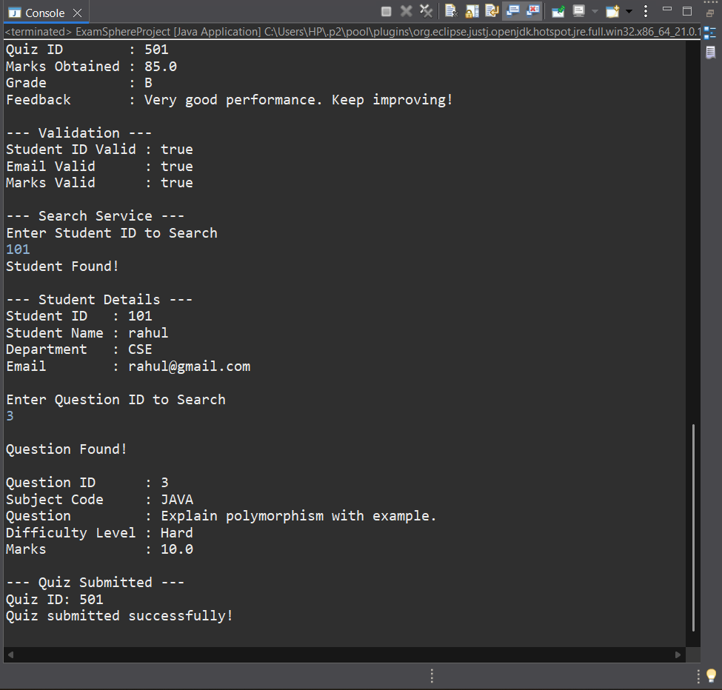

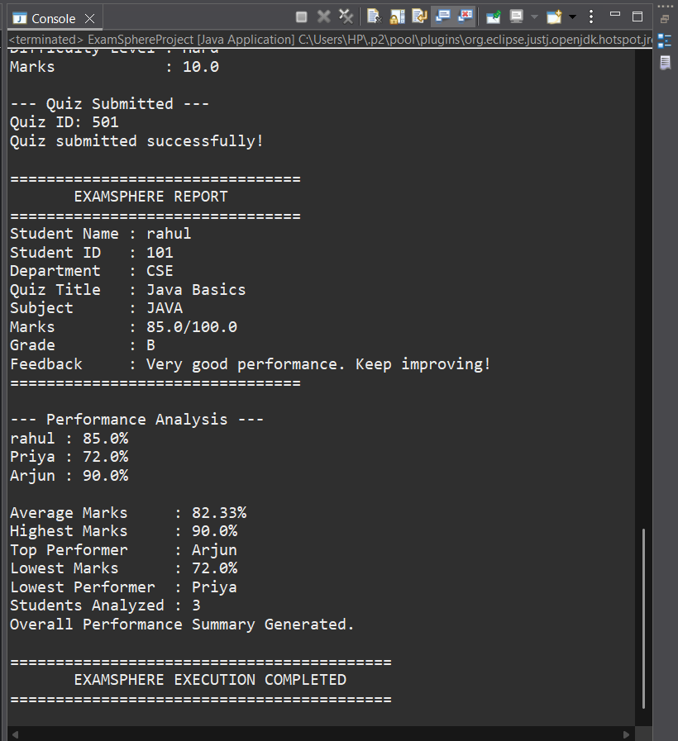
27

19

CONCLSION

The ExamSphere – Adaptive Quiz & Exam Engine project successfully demonstrates the development of a structured and personalized examination system using Java. The system integrates multiple modules for student management, question management, quiz and examination processing, adaptive question selection, result generation, validation, searching, report generation, and performance analysis.

The Adaptive Engine provides a personalized assessment experience by adjusting question difficulty according to student performance. The Result and AnalysisService modules further support the evaluation process by generating marks, grades, feedback, average performance, highest marks, top performer, and lowest performer details.

The project provided practical experience in applying important Java concepts, including Object-Oriented Programming, Classes and Objects, Encapsulation, Inheritance, Polymorphism, Exception Handling, Collections, Lambda Expressions, and Stream API. The modular design also improves the organization, readability, and maintainability of the application.

Overall, ExamSphere provides a strong foundation for an efficient and personalized examination system. The project can be further enhanced by integrating database connectivity, web or mobile interfaces, secure online examinations, larger question banks, and more advanced adaptive algorithms.

28

